# **TO SUPPLY LEFTOVER FOOD TO POOR**

## **INTRODUCTION:**

In this project, I utilized Salesforce, a leading CRM platform, to build a solution that helps in distributing leftover food to the needy. Salesforce provided me with various customization options to set up objects, automation, and reports. This project aims to resolve the problem of food wastage by efficiently collecting surplus food from venues and distributing it to drop-off points using volunteer support. The platform's flexibility allowed me to create an application that can manage the complete lifecycle of food collection and distribution.  
  
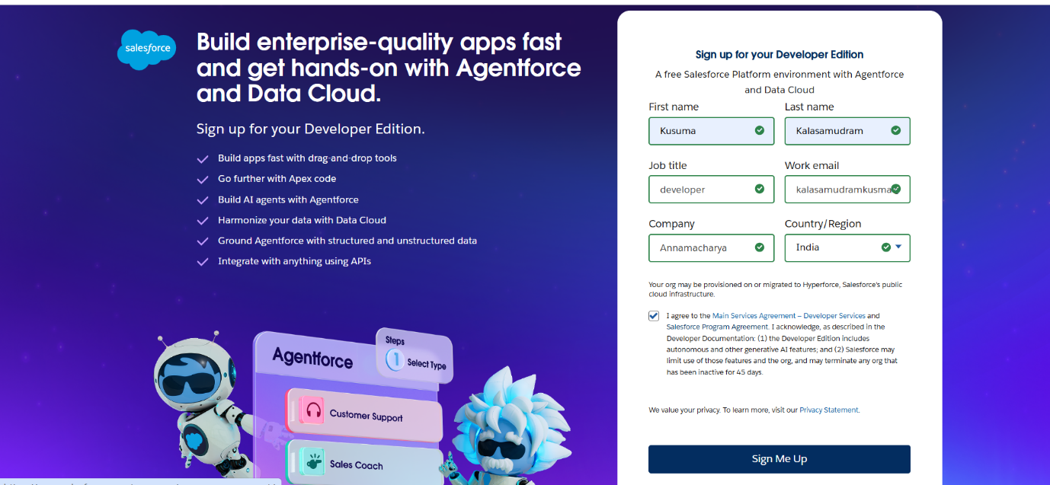

**PROJECT OVERVIEW**

The food distribution project in salesforce is designed to streamline the process of collecting and distributing leftover food to those in need. The project uses salesforce object and automation tools to manage venues (where food is collected), drop-off points (where food is distributed), tasks (for managing food pickup and delivery), volunteers, and execution details for each distribution event. Key objects in the system include venue, drop-off point, task, volunteer, and execution details, each object captures essential data, such as venue locations, volunteer assignments, and food distribution statistics, enabling efficient tracking and coordination of the distribution process

**Key features supporting the project**For the “supply leftover food to the poor” project, salesforce can enhance operations through:

**Data management**: centralized storage of donor information, distribution points and logistical data.

**Real-time reporting and analytics**: allows for monitoring food supply levels, analysing and generating reports to improve efficiency.

**Mobile accessibility**: ensure volunteers and team members can update and access information on the go, a crucial feature for field operations in food distribution.

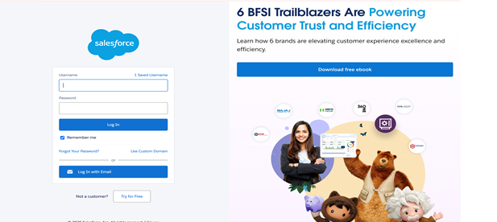

Give the username and password to login then go for setup  
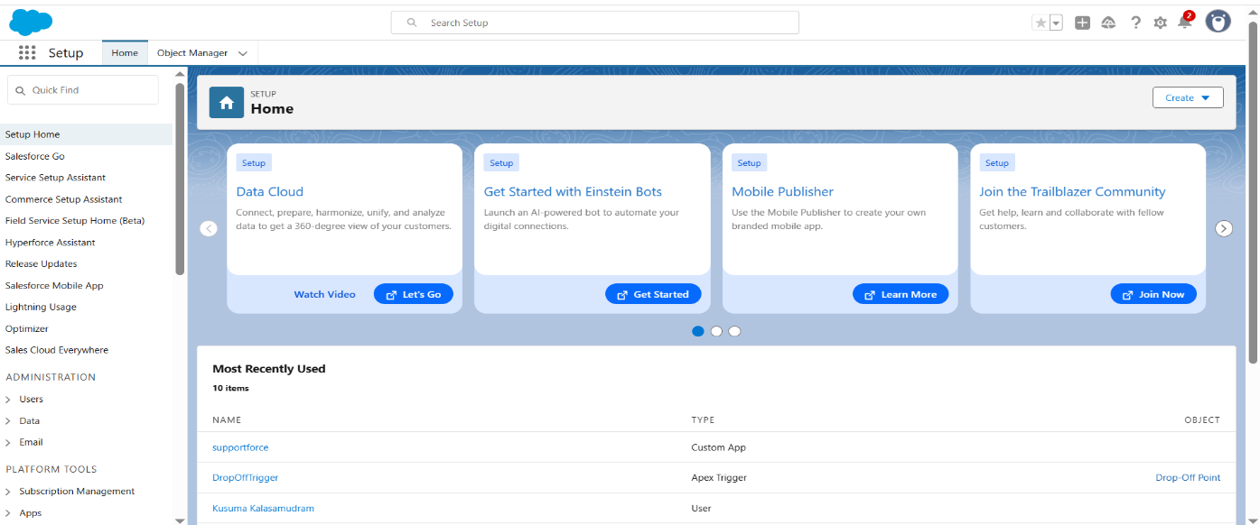  
  
**OBJECTIVE**

The main objective of this project is to build a simple yet powerful Salesforce application that helps streamline food donation and volunteer management processes. The goal is to:

* Reduce food wastage
* Assign volunteers effectively
* Generate performance reports
* Make NGO processes more organized and transparent.

**OBJECTCREATION:**  
  
In this project, I created five custom objects in Salesforce to store all necessary information regarding food collection, delivery points, volunteer assignments, and task execution. Below are the steps I followed to create each object:  
1.**VENUE:**  
**Purpose**: Stores information about food collection points.

* **Steps**: Setup ➝ Object Manager ➝ Create ➝ Custom Object
* Label Name: **Venue**
* Plural Label: **Venues**
* Record Name: **Venue Name** (Text)
* Enable: Allow Reports, Track Field History, Allow Activities, Allow Search.
* Click**Save**.

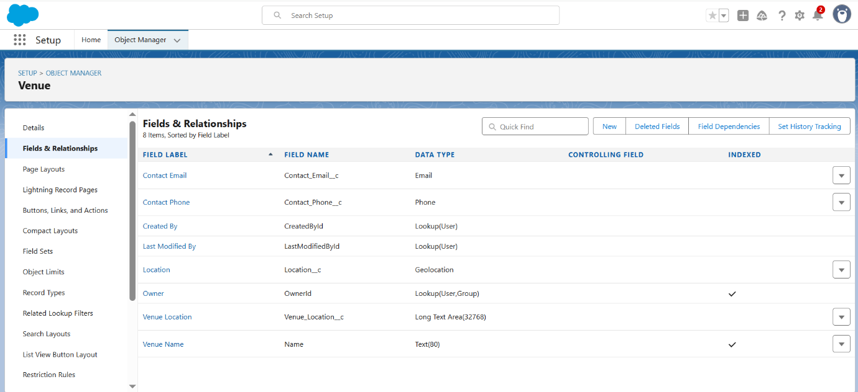

**2.DROP-OFFPOINT:**  
  
**Purpose**: Stores data about food delivery locations.

* **Steps**: Setup ➝ Object Manager ➝ Create ➝ Custom Object
* Label Name: **Drop-Off Point**
* Plural Label: **Drop-Off Points**
* Record Name: **Drop-Off Point Name** (Text)
* Enable: Allow Reports, Track Field History, Allow Activities, Allow Search.
* Click**Save**.  
    
  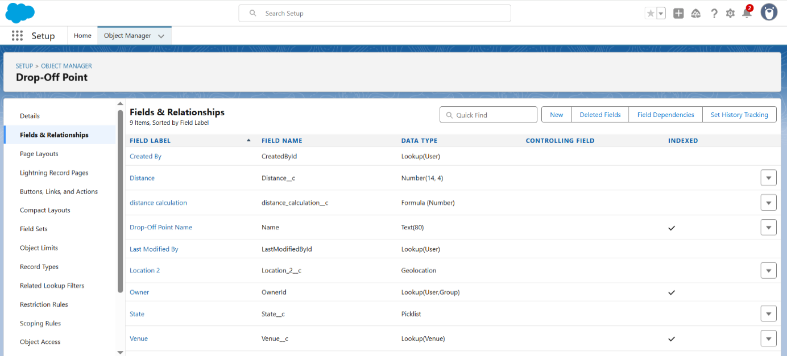

**3. TASK:**

* **Purpose**: Tracks tasks like food pickup and delivery assignments.
* **Steps**: Setup ➝ Object Manager ➝ Create ➝ Custom Object
  + Label Name: **Task**
  + Plural Label: **Tasks**
  + Record Name: **Task Name** (Text)
  + Enable: Allow Reports, Track Field History, Allow Activities, Allow Search.
  + Click **Save**.

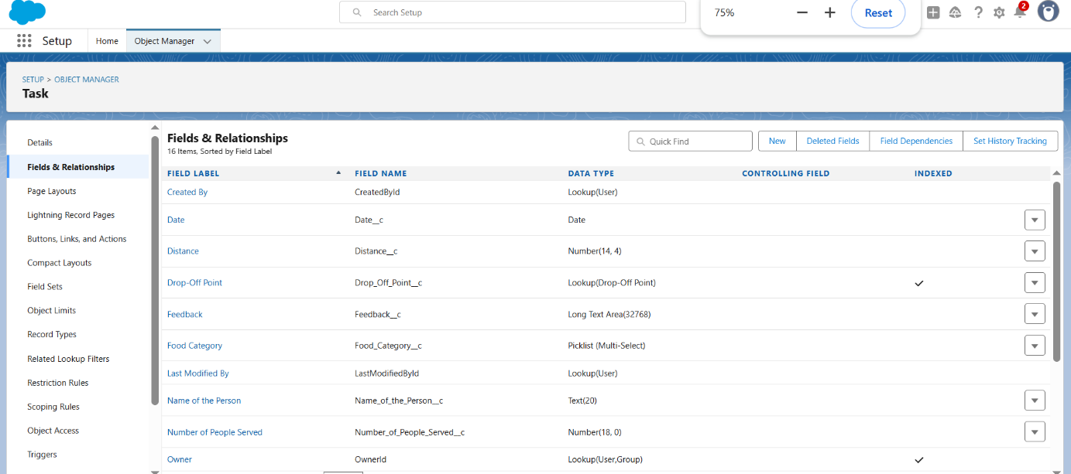

**4. VOLUNTEER:**

* **Purpose**: Stores volunteer details such as contact and availability.
* **Steps**: Setup ➝ Object Manager ➝ Create ➝ Custom Object
* Label Name: **Volunteer**
* Plural Label: **Volunteers**
* Record Name: **Volunteer Name** (Text)
* Enable: Allow Reports, Track Field History, Allow Activities, Allow Search.
* Click **Save**.

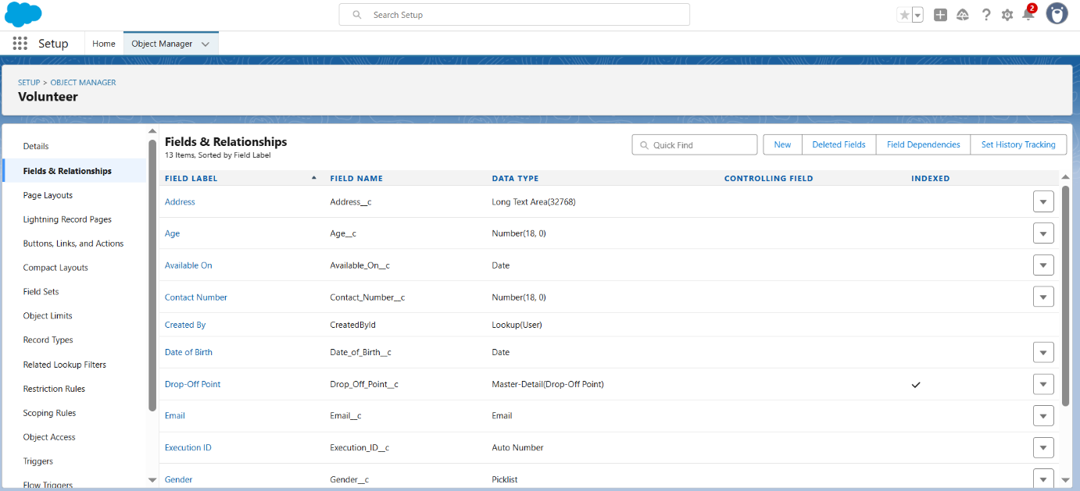

**5. EXECUTION DETAIL:**

**Purpose**: Records the execution details of food deliveries.

* **Steps**: Setup ➝ Object Manager ➝ Create ➝ Custom Object
* Label Name: **Execution Detail**
* Plural Label: **Execution Details**
* Record Name: **Execution Detail Name** (Text)
* Enable: Allow Reports, Track Field History, Allow Activities, Allow Search.
* Click **Save**.

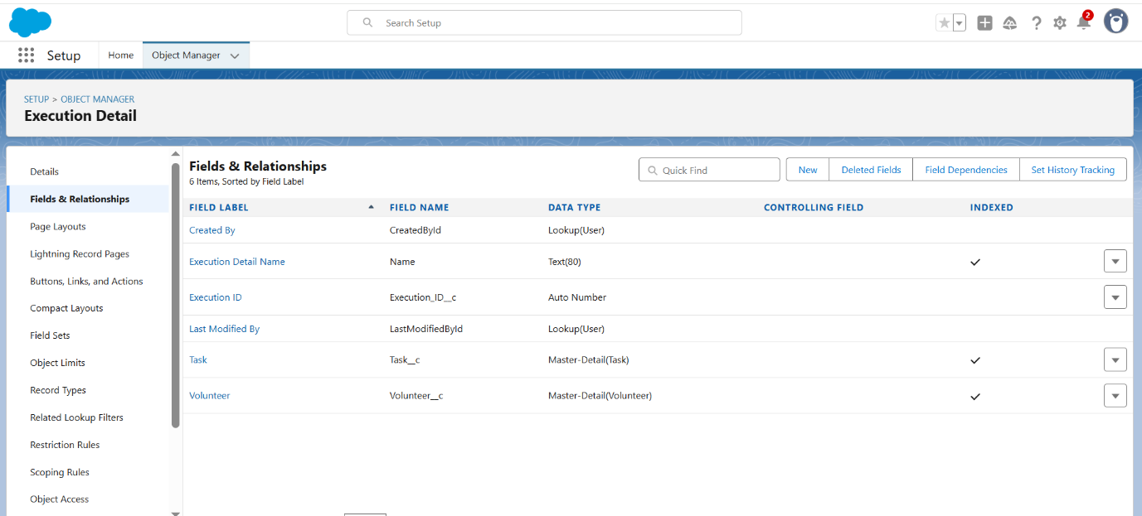

## **TAB CREATION**

In Salesforce, Tabs allow users to access and manage records of custom objects directly from the navigation menu. After creating my custom objects, I created individual tabs for each object so they can be easily accessible in the application.  
**Steps I Followed to Create Tabs in Salesforce:**

1. I logged into Salesforce and went to the **Setup** area (Gear Icon in the top-right corner).
2. In the **Quick Find Box**, I typed **Tabs** and selected the **Tabs** option from the setup menu.
3. On the Tabs page, I scrolled down to the section called **Custom Object Tabs**.
4. I clicked on the **New** button to start creating a new tab.

### **Tab Creation for Each Object:**

##### **For Venue Tab:**

* I selected the **Venue** object from the **Object** dropdown list.
* I chose a **Tab Style** (an icon representing Venue).
* I clicked **Next** on the **Add to Profiles** step, leaving profile visibility at default (visible for all profiles).
* On the **Add to Apps** screen, I unchecked the box **Include Tab** since I manually managed tabs in my app later.
* I checked **Append tab to users’ existing personal customizations** to make sure users can see the tab if added manually.
* I clicked **Save** to complete tab creation for Venue.

I repeated the exact same process for:

* **Drop-Off Point**
* **Task**
* **Volunteer**
* **Execution Detail**

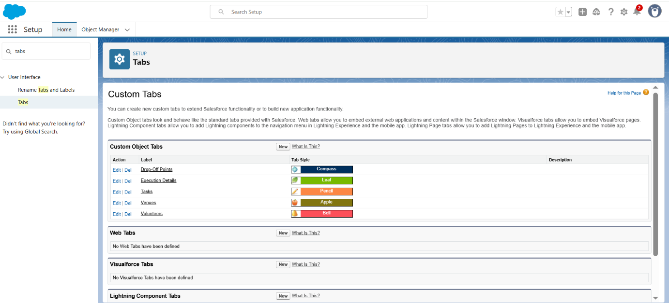

# **LIGHTNING APP CREATION**

# To create a Lightning App in Salesforce, follow these steps:

# **Step 1:** Navigate to App Manager

# • Go to Setup

# • Type “App Manager” in the Quick Find bar

Click on App Manager

• Click “New Lightning App”

**Step 2:** App Details and Branding

• App Name: FoodConnect

• Developer Name: (Auto-populated)

• Image: Optional

• Primary Colour: Use default

• Click Next

**Step 3:** App Options

• Navigation Style: Select Standard Navigation

• Click Next

**Step 4:** Utility Items

• Keep default settings

• Click Next

**Step 5:** Add Navigation Items

• From the list, search and select the following:

• Home

• Venue

• Drop-Off Point

• Task

• Volunteer

• Execution Details

• Reports

• Use the arrow to add them

• Click Next, then Next again

**Step 6:** Assign User Profiles

Search for System Administrator

• Move it using the arrow

• Click Save & Finish

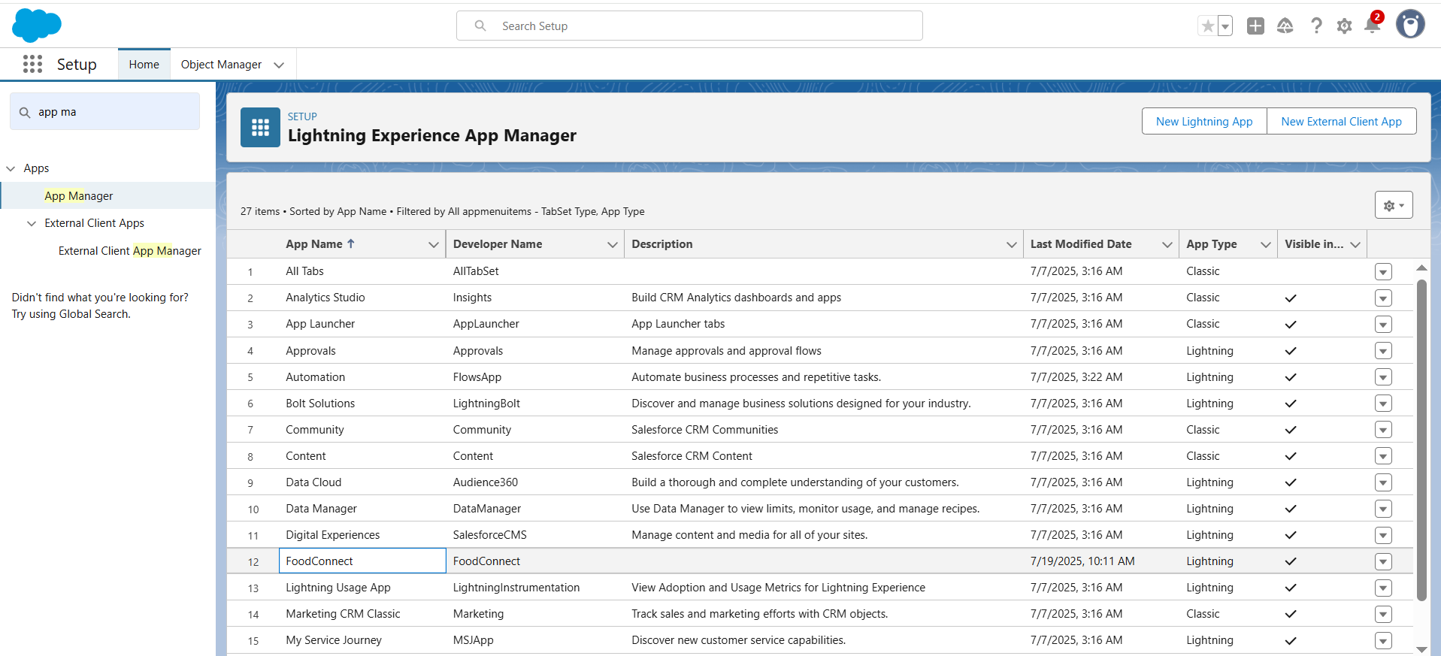

**Creation of Relationship Fields in Salesforce Objects**

1. Lookup Relationship on Volunteer Object

• Path: Setup → Object Manager → Volunteer → Fields & Relationships → New

• Type: Lookup Relationship

• Related Object: Drop-Off Point

• Field Name: Drop_Off_point

• Label: Auto-generated

• Click Next → Next → Save

1. Master-Detail Relationship on Execution Details (to Volunteer)

• Path: Setup → Object Manager → Execution Details → Fields & Relationships → New

• Type: Master-Detail Relationship

• Related Object: Volunteer

Field Name: Volunteer

• Label: Auto-generated

• Click Next → Next → Save

3. Master-Detail Relationship on Execution Details (to Task)

• Path: Setup → Object Manager → Execution Details → Fields & Relationships → New

• Type: Master-Detail Relationship

• Related Object: Task • Field Name: Task

• Label: Auto-generated • Click Next → Next → Save

4. Lookup Relationship on Drop-Off Point (to Venue)

• Path: Setup → Object Manager → Drop-Off Point → Fields & Relationships → New

• Type: Lookup Relationship

• Related Object: Venue

• Field Name: Venue

• Label: Venue__c

• Click Next → Next → Save

5. Lookup Relationship on Task (to Venue)

• Path: Setup → Object Manager → Task → Fields & Relationships → New

• Type: Lookup Relationship

• Related Object: Venue

• Field Name: Sponsored By

• Label: Auto-generated

• Click Next → Next → Save

6. Lookup Relationship on Task (to Drop-Off Point)

• Path: Setup → Object Manager → Task → Fields & Relationships → New

• Type: Lookup Relationship

• Related Object: Drop-Off Point

• Field Name: Drop-Off point

• Label: Auto-generated

• Click Next → Next → Save

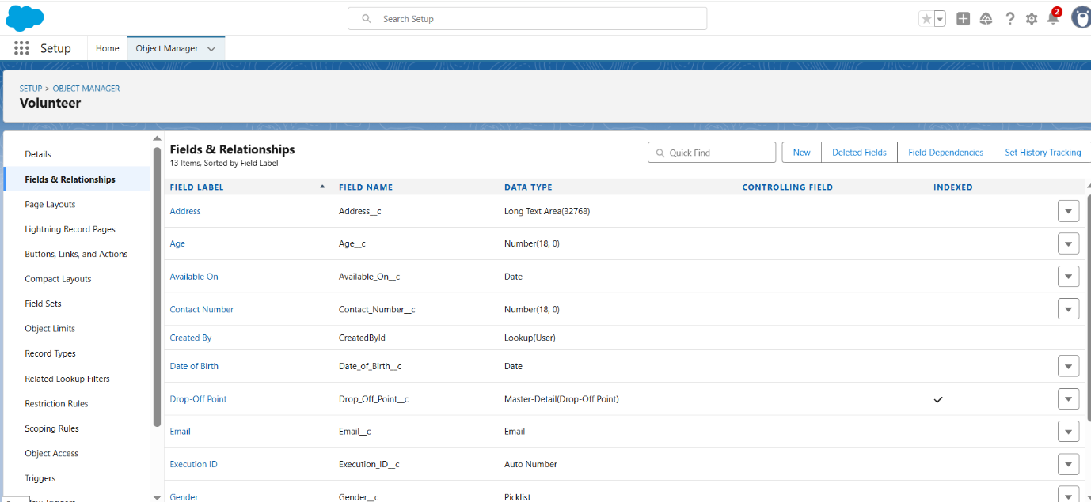

# **PHASE Creation of Fields in Venue Object**

# 1. Create Email Field

# • Navigation:

# Setup → Object Manager → Venue → Fields & Relationships → New

# • Data Type: Email

# • Field Label: Contact Email

# • Field Name: Auto-populated

# • Required: Checked

# • Click Next → Next → Save & New

2. Create Phone Field

• Navigation: Setup → Object Manager → Venue → Fields & Relationships → New

• Data Type: Phone

• Field Label: Contact Phone

• Field Name: Auto-populated

• Required: Checked

• Click Next → Next → Save & New

3. Create Geolocation Field

• Navigation: Setup → Object Manager → Venue → Fields & Relationships → New

• Data Type: Geolocation

• Field Label: Location

• Decimal Places: 4

• Field Name: Auto-populated

• Description: Enter the Geolocation of your Venue

• Click Next → Next → Save & New

4. Create Long Text Area Field

• Navigation: Setup → Object Manager → Venue → Fields & Relationships → New

• Data Type: Long Text Area

• Field Label: Venue Location

• Field Name: Venue_Location

• Click Next → Next → Save

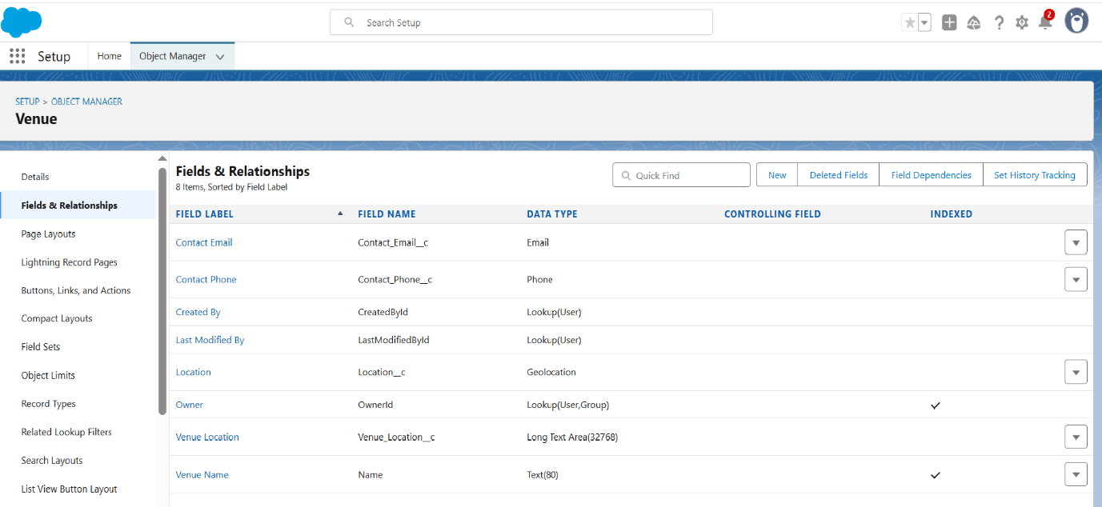

**Creation of Fields in Drop-Off Point Object**

1. Geolocation Field – Location 2

• Navigation:

Setup → Object Manager → Drop-Off Point → Fields & Relationships → New

• Data Type: Geolocation

• Field Label: Location 2

• Field Name: Auto-generated

• Description: Enter the Geolocation of the Drop off Point

• Geolocation Option: Decimal

• Decimal Places: 4

• Click Next → Next → Save & New

2. Formula Field – Distance Calculation

• Navigation:

Setup → Object Manager → Drop-Off Point → Fields & Relationships → New

• Data Type: Formula

• Field Label: distance calculation

• Field Name: distance_calculation

• Formula Return Type: Number

• Formula: scss CopyEdit DISTANCE (Location_2__c, Venue__r.Location__c, "km")

• Click Next → Next → Save & New

3. Picklist Field – State

• Navigation: Setup → Object Manager → Drop-Off Point → Fields & Relationships → New • Data Type: Picklist

• Field Label: State

• Field Name: State

• Values (one per line): Puducherry (UT)

• Required: Checked

• Click Next → Next → Save & New Creation of Field in Task Object Number Field – Distance

• Navigation: Setup → Object Manager → Task → Fields & Relationships → New

• Data Type: Number

• Field Label: Distance

• Field Name: Distance

• Length: 14

• Decimal Places: 4

• Required: Checked

• Click Next → Next → Save

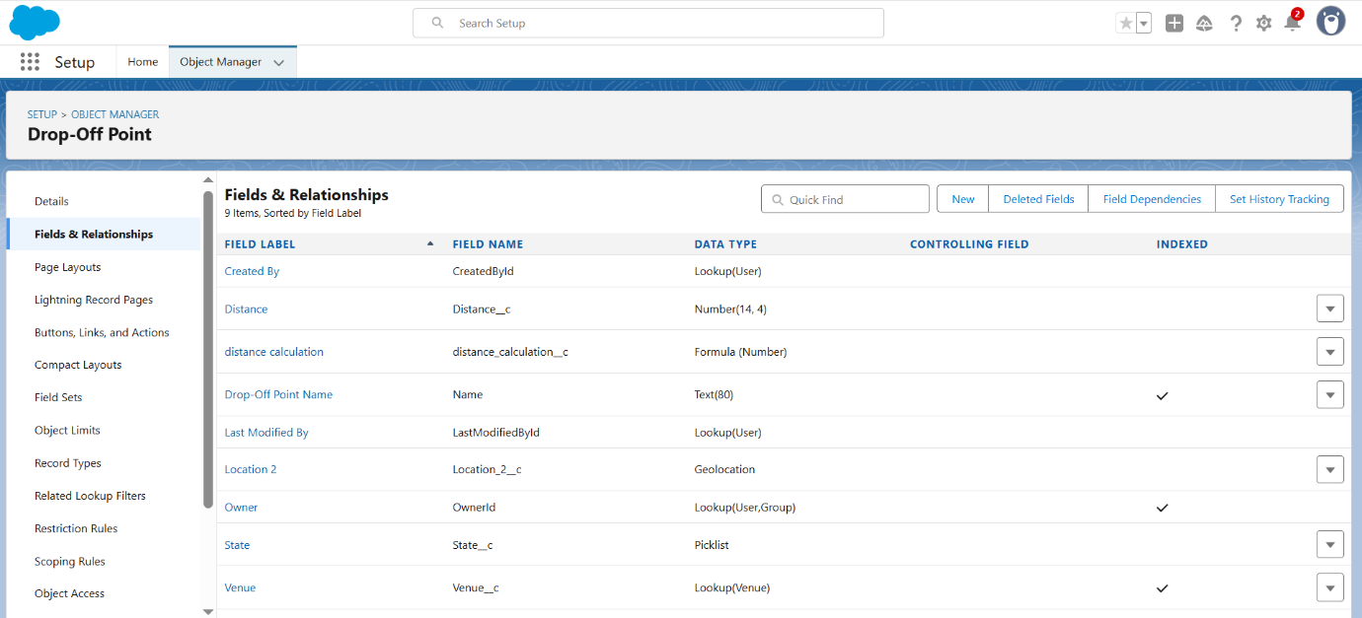

**Creation of Fields in Task Object**

**1. Auto Number Field – Task ID**

• Navigation:

Setup → Object Manager → Task → Fields & Relationships → New

• Data Type: Auto Number

• Field Label: Task ID

• Display Format: TASK-{0}

• Starting Number: 1

• Required: Checked

• Click Next → Next → Save & New

2. Date Field – Date

• Data Type: Date

• Field Label: Date

• Field Name: Date

• Required: Checked

• Click Next → Next → Save & New

3. Picklist (Multi-Select) – Food Category

• Data Type: Picklist (Multi-Select)

• Field Label: Food Category

• Field Name: Food_Category

• Picklist Values:

• Required: Checked

• Click Next → Next → Save & New

4. Number Field – Number of People Served

• Data Type: Number

• Field Label: Number of People Served

• Field Name: Number_of_People_Served

• Required: Checked

• Click Next → Next → Save & New

5. Text Field – Name of the Person

• Data Type: Text

• Field Label: Name of the Person

• Field Name: Name_of_the_Person

• Click Next → Next → Save & New

6. Phone Field – Phone

• Data Type: Phone

• Field Label: Phone

• Field Name: Phone

• Click Next → Next → Save & New

7. Picklist Field – Rating • Data Type: Picklist

• Field Label: Rating

• Field Name: Rating

• Picklist Values:

• Click Next → Next → Save & New

8. Long Text Area – Feedback

• Data Type: Long Text Area

• Field Label: Feedback

• Field Name: Feedback

• Click Next → Next → Save

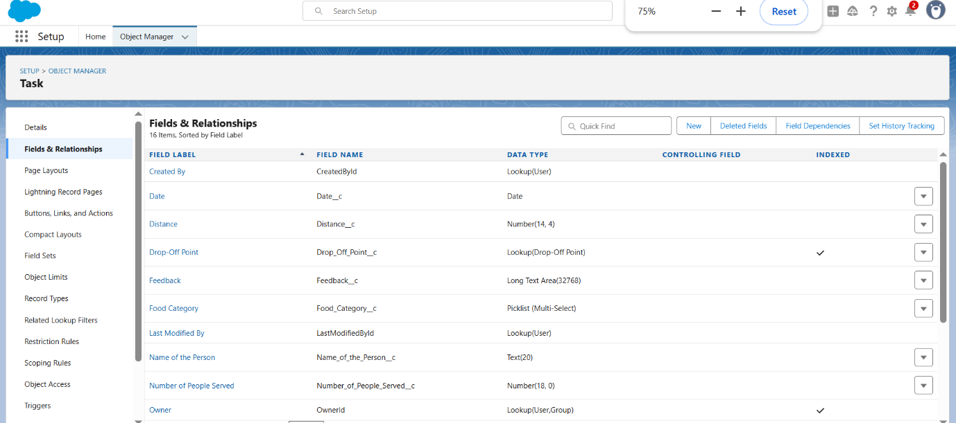

**Creation of Fields in Execution Details Object**

1. Auto Number – Execution ID

**Go to:**

Setup → Object Manager → Search for Execution Details

**Steps:**

1. Click on Fields & Relationships → New

2. Choose Data Type: Auto Number → Click Next

1. Field Label: Execution ID
2. Field Name: (Auto-generated)
3. Check the Required box
4. Click Next → Next → Save & New



**Create Flow to create a record in Venue object**

1. Go to setup >> type Flow in quick find box >> Click on the Flow and Select the New Flow.

2. Select the Screen flow. Click on create.

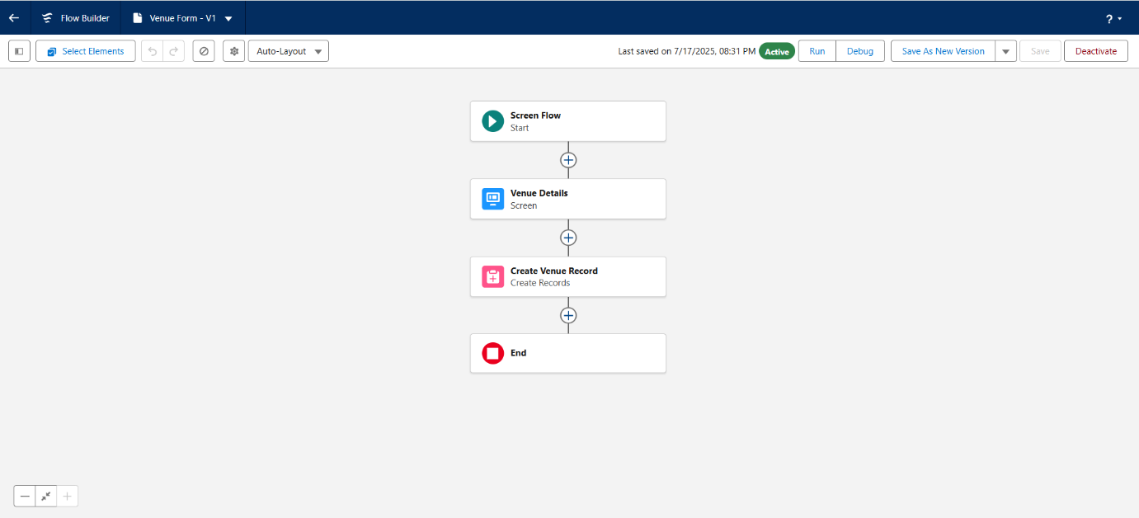

# **PHASE 1: REQUIREMENT ANALYSIS & PLANNING**

## **Understanding Business Requirements:**

* NGOs need a system to track food pick-up and drop-off points.
* Volunteers should be assigned automatically depending on their location.
* The system should provide live updates about tasks and volunteers.
* Managers should have dashboards to easily check distribution progress.

## **Defining Project Scope and Objectives:**

* I included custom objects for **Venues**, **Drop-Off Points**, **Volunteers**, **Tasks**, and **Execution Details**.
* I planned for user management using **Profiles** and **Public Groups**.
* Created reports and dashboards for simple monitoring.
* Added sharing rules to limit data access based on distance.
* Built automation using Flows and validation rules for efficiency.

## **Design Data Model and Security Model:**

* **Data Model**: Custom objects connected through Lookup and Master-Detail relationships.
* **Security Model**:
  + Custom **NGOs Profile** for users.
  + Simple hierarchy using **Public Groups**.
  + **Sharing Rules** to give access based on drop-off location distance.

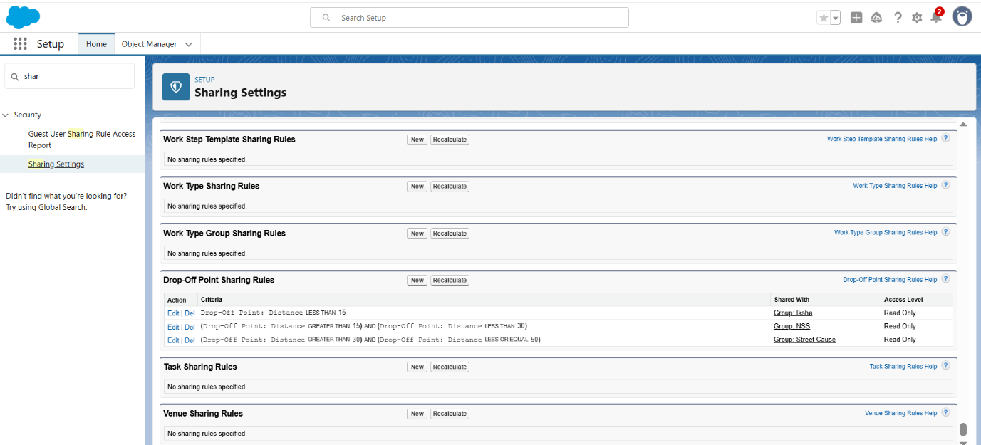

# **PHASE 2: SALESFORCE DEVELOPMENT – BACKEND & CONFIGURATIONS**

## **Setup Environment & Deployment:**

* I used a **Developer Org** for building and testing.
* Moved everything to production using **Change Sets**.

## **Objects, Fields, and Automation:**

* Created all necessary objects with custom fields like Distance and Ratings.
* Added validation rules to prevent errors during record creation.
* Built **Flows** to assign volunteers and create tasks automatically.

## **Apex and Triggers:**

* Only used one simple trigger for setting distance values.
* No complex Apex classes were needed in this project.

## **Apex and Triggers:**

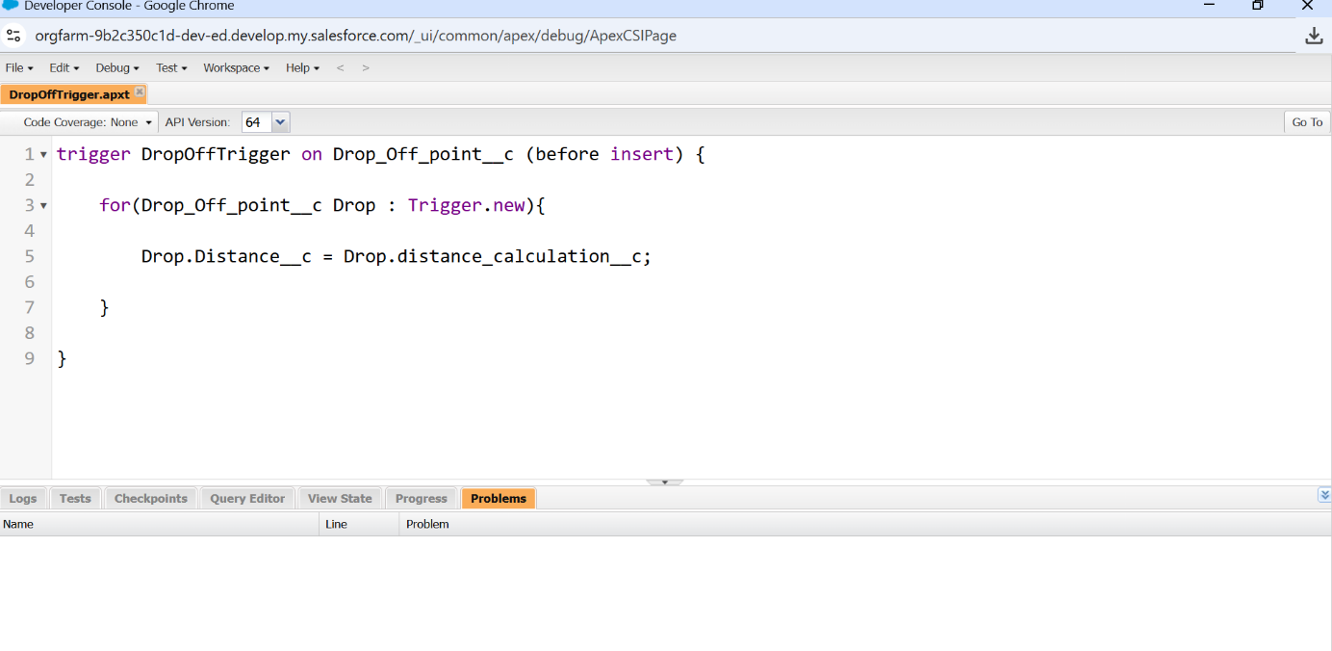

# **PHASE 3: UI/UX DEVELOPMENT & CUSTOMIZATION**

## **Lightning App:**

* Made a **Lightning App** called **FoodConnect** with all important tabs.

## **Page Layouts:**

* Adjusted page layouts to make sure every record shows the right information.
* Added related lists to connect venues, tasks, and volunteers.

## **User Management:**

* Created different NGO users with the **NGOs Profile**.
* Grouped users in **Public Groups** like Iksha, NSS, and Street Cause.

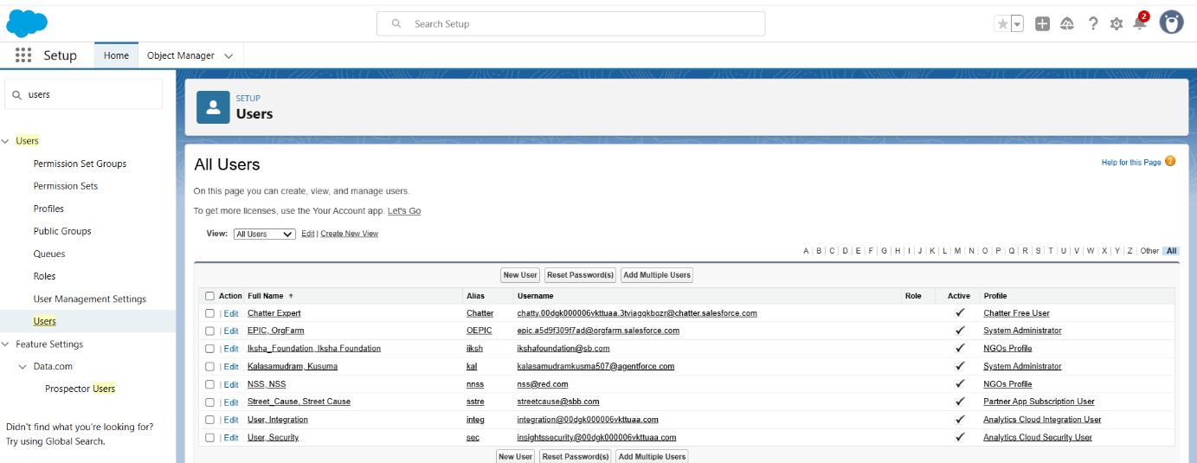

## **Reports and Dashboards:**

* Built two report types:
  + **Venue with Drop-Off and Volunteers**
  + **Volunteers with Tasks and Execution Details**
* Designed dashboards to track volunteers and food deliveries.

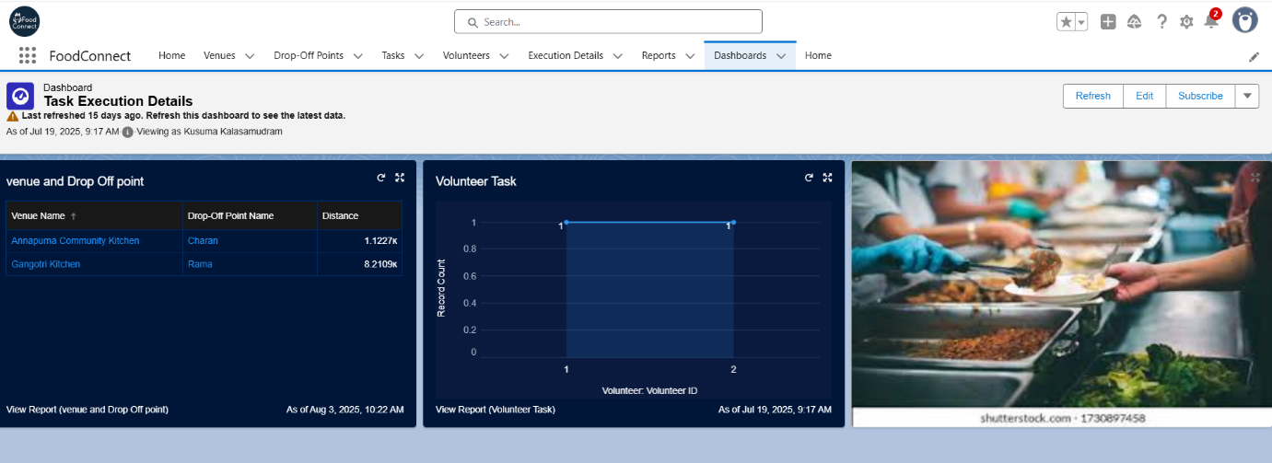

## **LWC Development:**

* I didn’t use Lightning Web Components (LWC) for this project.

## **Lightning Pages:**

* Customized **Lightning Pages** by adding flows and dashboards to the Home Page.

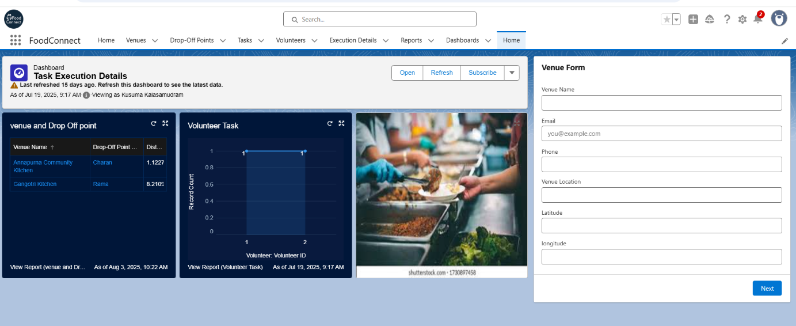

**PHASE 4: DATA MIGRATION, TESTING & SECURITY**

## **Data Importing:**

* Used **Data Import Wizard** for small records.
* Used **Data Loader** for bulk uploads.

## **Data Quality and Protection:**

* Enabled **Field History Tracking**.
* Set up **Duplicate Rules** on Volunteer emails.
* Created **Sharing Rules** based on distance.

## **Test Classes:**

* I did not need test classes since I used Flows, not complex code.**Testing Approach:**
* Manually tested all flows, tasks, and reports:
  + Volunteer gets assigned correctly
  + Tasks are auto-created
  + Reports show accurate data
* Verified dashboards after every update.

# **PHASE 5: DEPLOYMENT, DOCUMENTATION & MAINTENANCE**

## **Deployment:**

* Used **Outbound Change Sets** to move from Sandbox to Production.

## **Maintenance:**

* Admin is responsible for:
  + Monitoring users
  + Checking reports
  + Updating records regularly

## **Troubleshooting:**

* Used **Debug Logs** and error paths in Flows to solve issues quickly.
* Kept a record of updates using **Setup Audit Trail**.

# **CONCLUSION**

The FoodConnect CRM I developed provides a simple and organized solution for managing food donations by bringing together NGOs, volunteers, venues, and drop-off points in a single Salesforce platform. It helped automate volunteer assignments, track food delivery tasks, and generate real-time reports and dashboards, making the donation process faster and more efficient. By implementing custom objects, flows, and sharing rules, the system ensures better coordination, reduces manual work, and supports timely food distribution to those in need. This project also allows future upgrades like mobile access, AI-based volunteer matching, and advanced reporting features.

DEMO VIDEO GOOGLE DRIVE LINK:

<https://drive.google.com/file/d/1CAkCvA6WoVHHhNDfN-DOKBpmQUBKZC0t/view?usp=sharing>

GITHUB LINK:

https://github.com/Kusuma0103/FoodConnect___Project